What are Semantics Elements?

: Semantic elements = elements with a meaning.

A semantic element clearly describes its meaning to both the browser and the developer.
Examples of non-semantic elements: <div> and <span> - Tells nothing about its content.
Examples of semantic elements: <form>, <table>, and <article> - Clearly defines its content.

Many web sites contain HTML code like: <div id="nav"> <div class="header"> <div id="footer"> to indicate navigation, header, and footer.

El orden y el mapa de planteamiento de como quieres que quede el HTML es muy importante para mantener un documento bien armado y fácil para que cualquiera lo pueda leer.

In HTML there are some semantic elements that can
be used to define different parts of a web page:

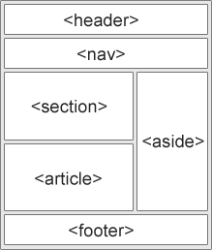
<article>
- <aside>
- <details>
- <figcaption>
- <figure>
- <footer>
- <header>
- <main>
- <mark>
- <nav>
- <section>
- <summary>
- <time>
HTML <section> Element
The <section> element defines a section in a document.
According to W3C's HTML documentation: "A section is a thematic grouping of content, typically with a heading."
Examples of where a <section> element can be used:
- Chapters
- Introduction
- News items
- Contact information
A web page could normally be split into sections for introduction, content, and contact information.
EJEMPLO:

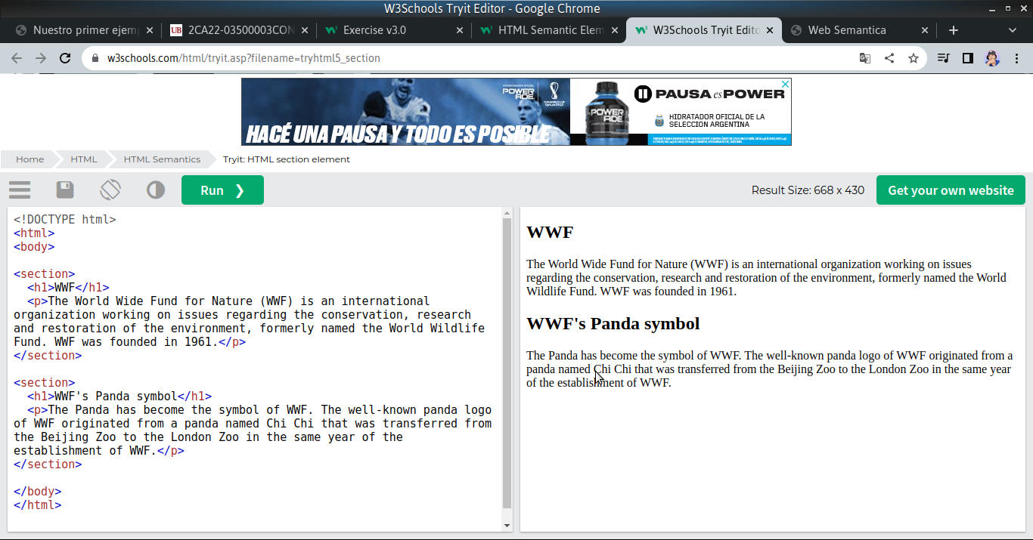

HTML <article> Element
The <article> element specifies independent, self-contained content.
An article should make sense on its own, and it should be possible to distribute it independently from the rest of the web site.
Examples of where the <article> element can be used:
- Forum posts
- Blog posts
- User comments
- Product cards
- Newspaper articles
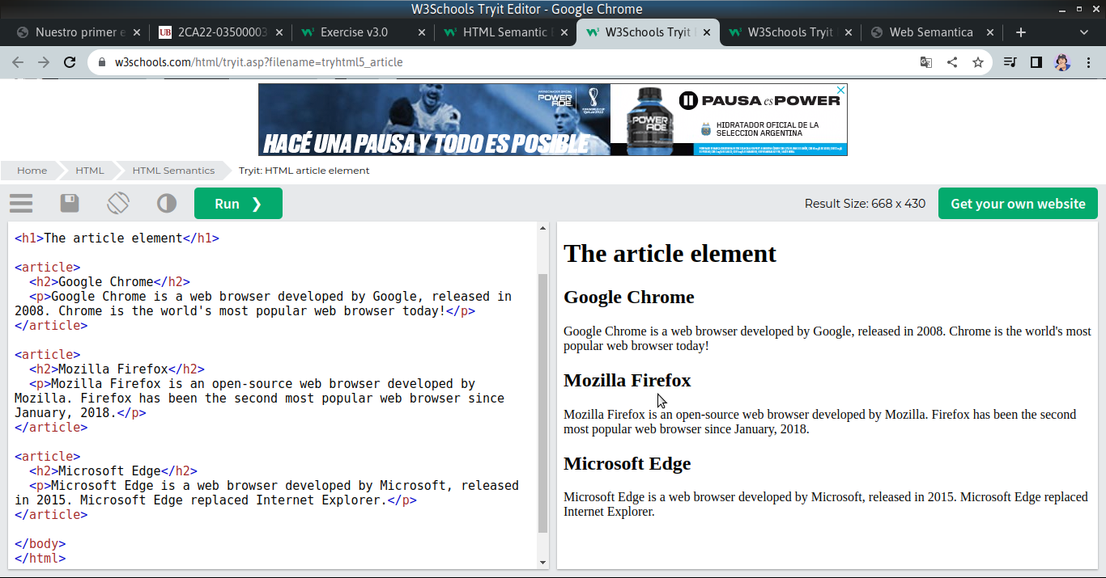

Nesting <article> in <section> or Vice Versa?
The <article> element specifies independent, self-contained content.

The <section> element defines section in a document.

Can we use the definitions to decide how to nest those elements? No, we cannot!

So, you will find HTML pages with <section> elements containing <article> elements, and <article> elements containing <section> elements.

HTML <header> Element
The <header> element represents a container for introductory content or a set of navigational links.
A <header> element typically contains:
- one or more heading elements (<h1> - <h6>)
- logo or icon
- authorship information
Note: You can have several <header> elements in one HTML document. However, <header> cannot be placed within a <footer>, <address> or another <header> element.

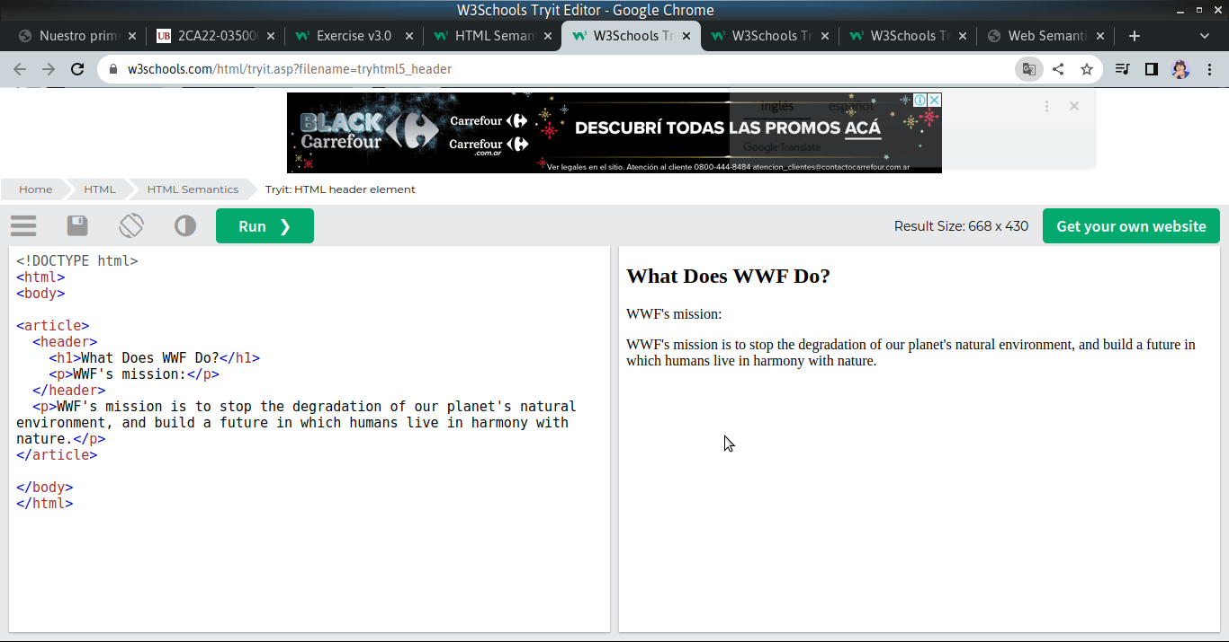

HTML <footer> Element
The <footer> element defines a footer for a document or section.
A <footer> element typically contains:
- authorship information
- copyright information
- contact information
- sitemap
- back to top links
- related documents
You can have several <footer> elements in one document.

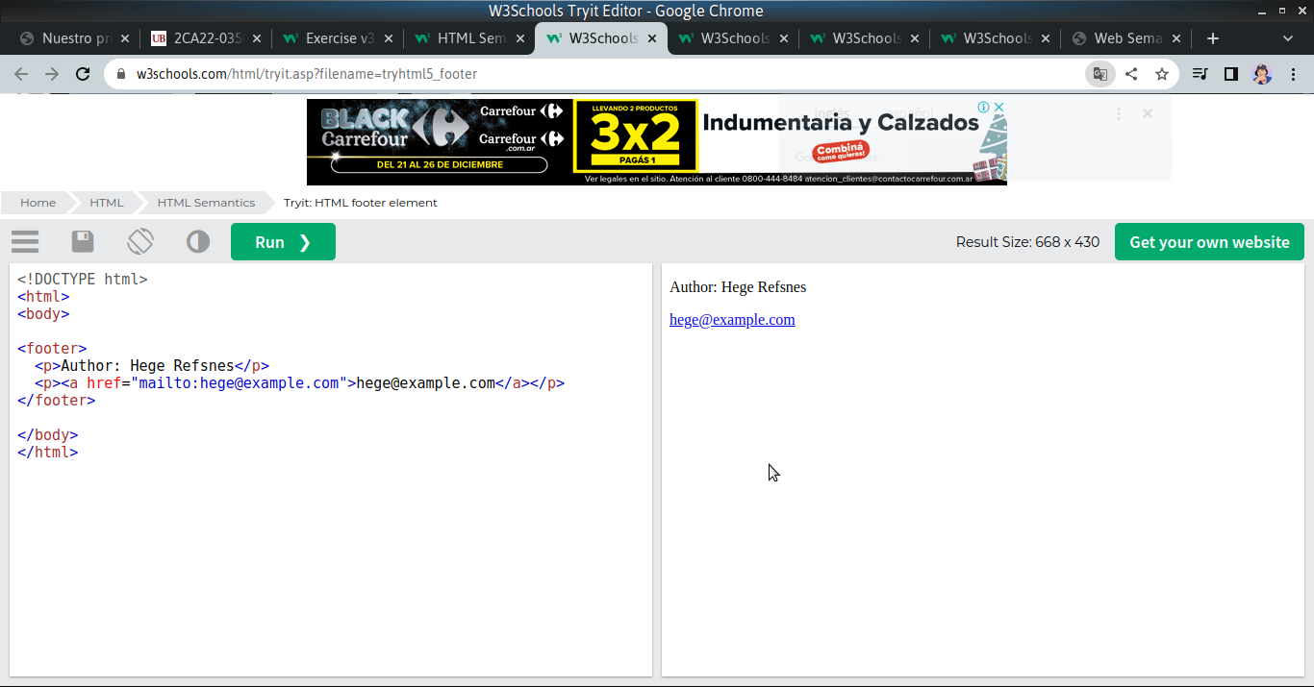

HTML <nav> Element
The <nav> element defines a set of navigation links.
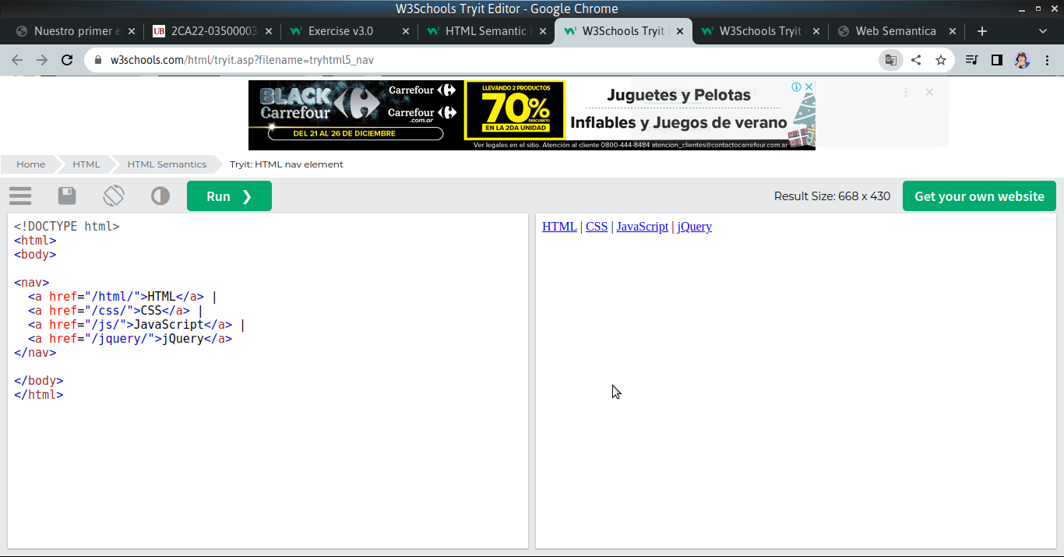

HTML <aside> Element
The <aside> element defines some content aside from the content it is placed in (like a sidebar).
The <aside> content should be indirectly related to the surrounding content.
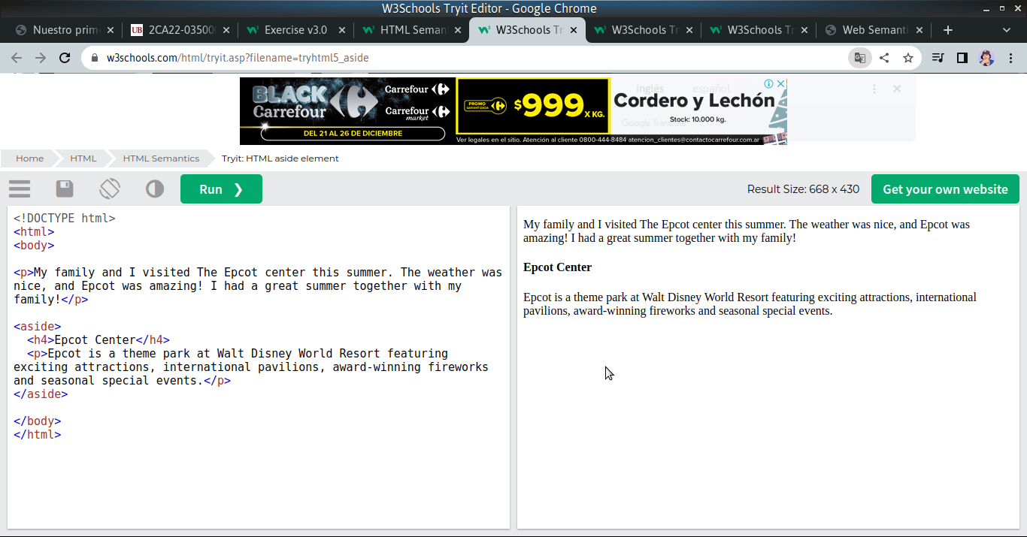

HTML <figure> and <figcaption> Elements
The <figure> tag specifies self-contained content, like illustrations, diagrams, photos, code listings, etc.
The <figcaption> tag defines a caption for a <figure> element. The <figcaption> element can be placed as the first or as the last child of a <figure> element.
The <img> element defines the actual image/illustration.
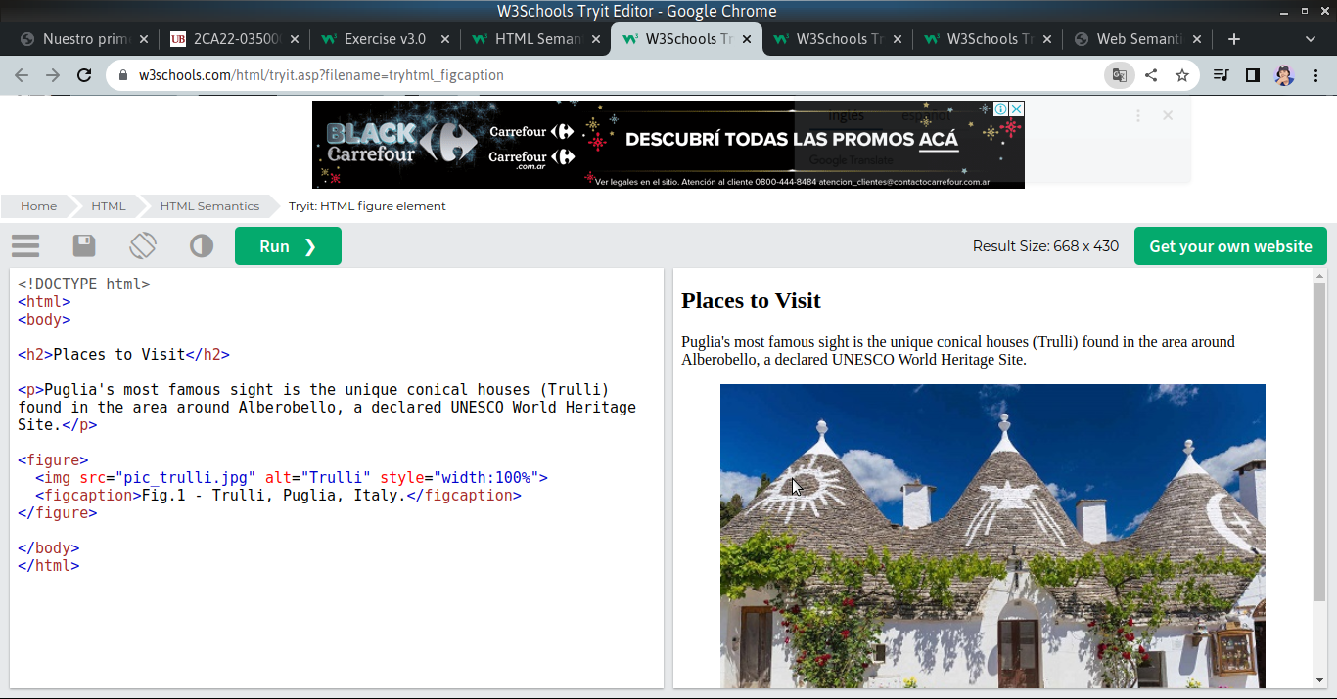

Semantic Elements in HTML
Below is a list of some of the semantic elements in HTML.
Tag | Description
<article> | Defines independent, self-contained content
<aside> | Defines content aside from the page content
<details> | Defines additional details that the user can view or hide
<figcaption> | Defines a caption for a <figure> element
<figure> | Specifies self-contained content, like illustrations, diagrams, photos, code listings, etc.
<footer> | Defines a footer for a document or section
<header> | Specifies a header for a document or section
<main> | Specifies the main content of a document
<mark> | Defines marked/highlighted text
<nav> | Defines navigation links
<section> | Defines a section in a document
<summary> | Defines a visible heading for a <details> element
<time> | Defines a date/time

